RAPPORT PROJET-INFO

Victor CHANUSSOT

ECAM 2025



TABLE OF CONTENTS

* 1 ) Project Presentation
  1. Global presentation of the idea
  2. Website architecture and design
* 2 ) Progress and obstacles
  1. HTML/CSS
  2. Database/PHP
* 3 ) Conclusion

# **Project Presentation**

1. Global presentation of the idea

I was first tempted to make a portfolio about myself and my own training/experiences as a firefighter (pompier volontaire dans mon cas) but I was missing lots of true experiences, pictures, and information.

Therefore, I wasn’t very content with the plan I had mapped in my head for the website, and decided to start brainstorming again and find a subject that I was interested in and on which I had loads of information at my disposition. Luckily, I had recently watched Fight Club, a classic movie starring Brad Pitt as Tyler Durden, and I eventually decided to stick with the portfolio concept but to make it about him instead.

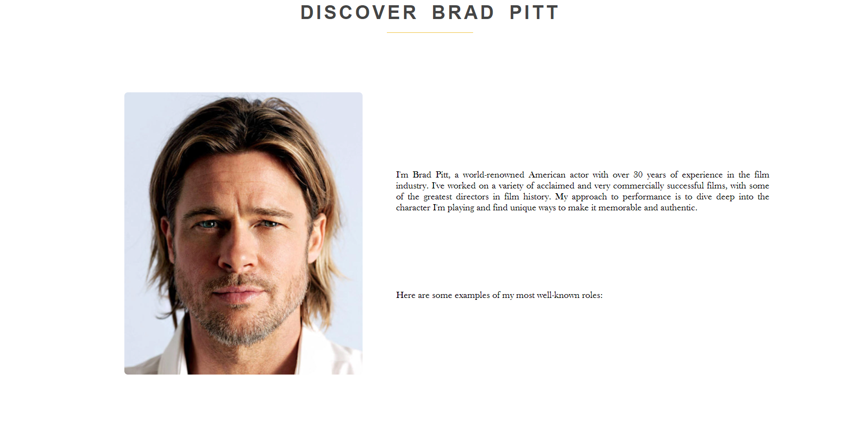

# Website architecture and design

As for the architecture of my portfolio, I decided to keep it subtle, on one page only where you can just scroll down to the end where you will find the actor’s social networks, as well as a contact link and a place to enter users’ information.

The design is clean and simple, and the information is well displaced and organized. We can find a collection of some of Brad’s most popular movies as well as a couple other accomplishments and missions he was involved in.

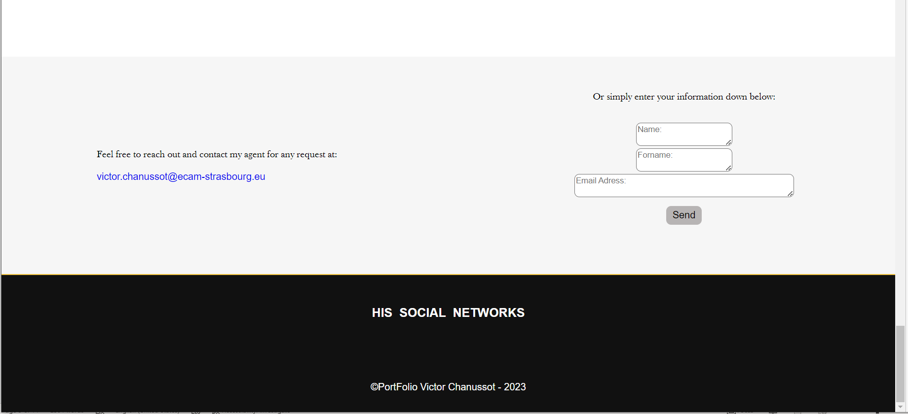

# **Progress and obstacles**

1. HTML/CSS

As most people would, I got started on my website project with coding the front end of the site first, to make sure the site had the exact appearance I had in mind and I was satisfied with it. I did struggle a bit, more so on the styling part of the code, as it was the bit which I was the least familiar in. I helped myself with a few bootlegs I found online as well as tips from friends, and eventually reached the minimalist appearance I desired and was set to achieve.

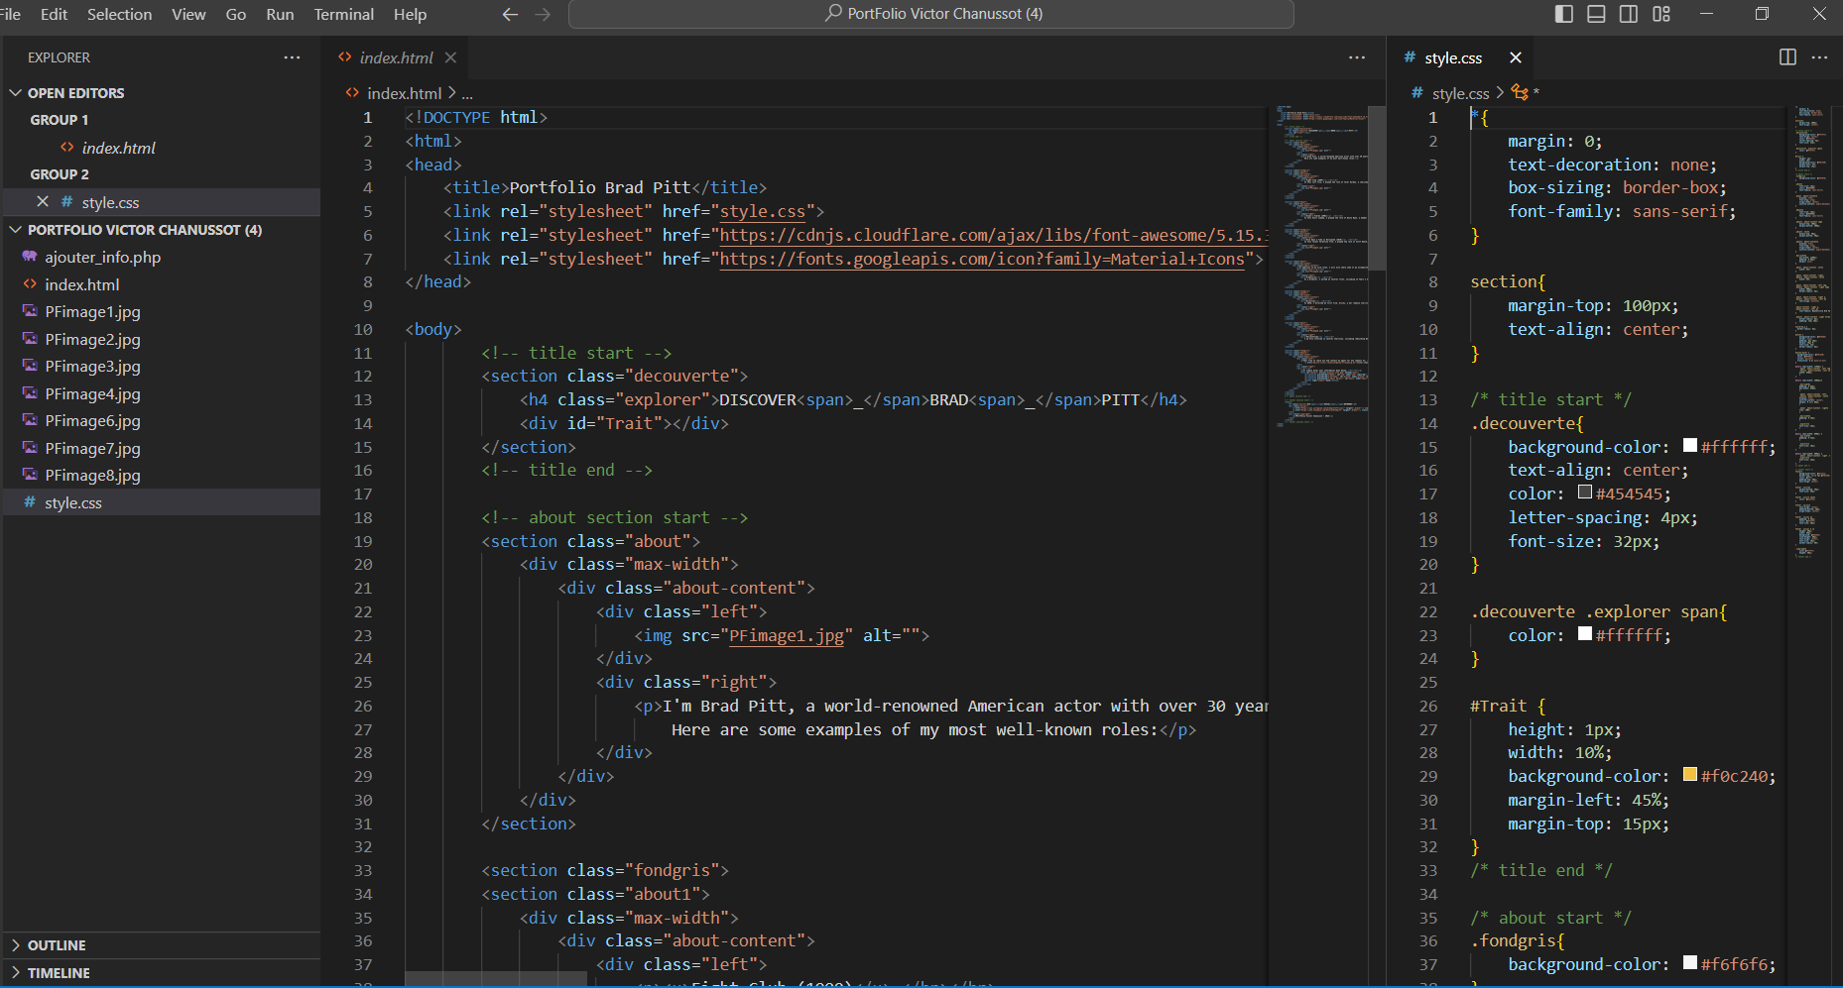

1. Database/PHP

As for the database, I created one in phpMyAdmin while using xampp to access the admin section. I tried to make a connect.php code to link the site with the database table but I couldn’t find a way to solve the problem. I looked for solutions with my colleagues and online, but I couldn’t find a way to make it work so that the forms on my site would retrieve the information inputed and send it to my database. I even solicitated Mayeul’s help to show me how he created his and connected it but he couldn’t figure it out either. I would always get the same error message and can’t understand where it’s coming from.Text

**Conclusion**

To conclude, creating such a project on my own actually forced me to be trained in most of the required skills for web designing. It had been a while since I had sharpened my HTML/CSS skillset specifically. It was an interesting but time-consuming process. It’s a shame I couldn’t manage to connect my database to my website so that the form would send the data straight into my data table but I was quite busy with other exams so I got started on the back end coding a bit late. I am glad however that this project helped me be more independent and knowledgeable on the process of creating a website.